Virtual Functions

Scenario | Vtable Created? | Why?
Class with no virtual function | ❌ | No need for dynamic dispatch
Class with one or more virtual functions | ✅ | Required for polymorphism
Class inherits a virtual function | ✅ | It’s part of vtable inheritance
Abstract class with pure virtual | ✅ | Must be overridden, managed via vtable

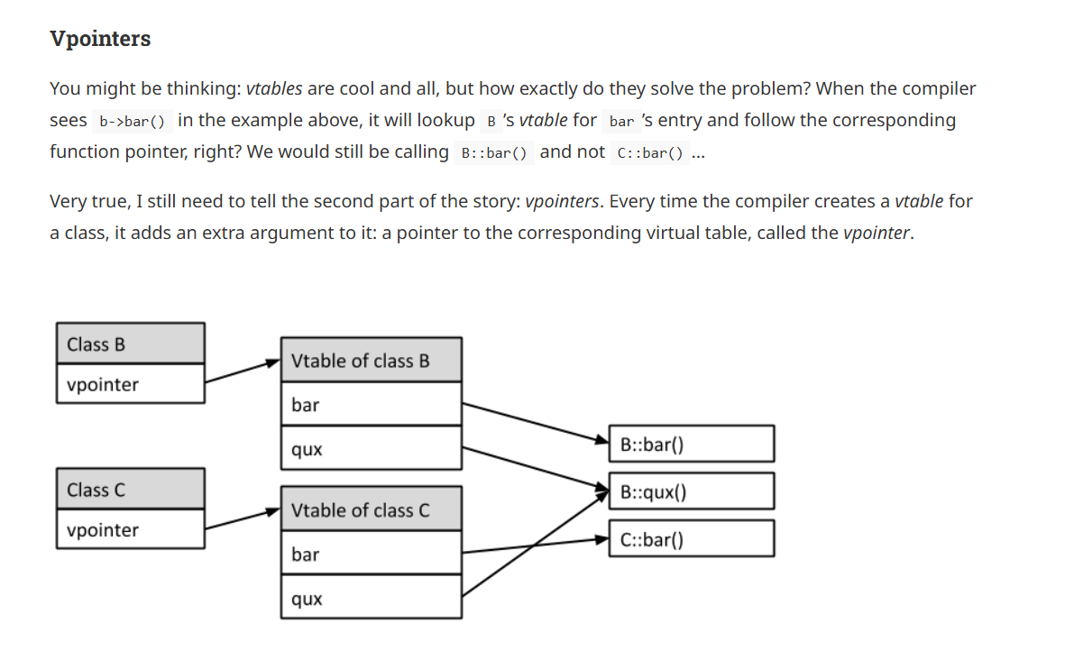:
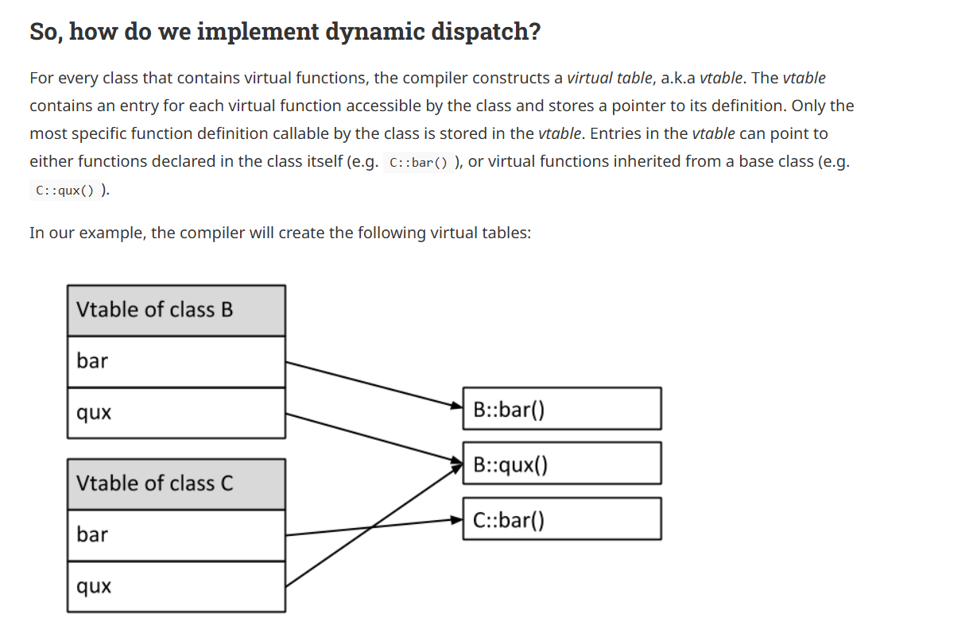

Virtual Functions in Java:

Exactly! 🤓 You nailed it.
In Java, unlike C++, the behavior is flipped:

✅ In Java:
By default, all instance methods are virtual — meaning:
- The actual method that gets called is determined at runtime based on the object's actual type, not the reference type.
🔑 Exceptions (i.e., NOT virtual):
- final methods → Can't be overridden
- private methods → Not visible to subclasses
- static methods → Belong to class, not instance

🔁 Java Method Virtuality Summary
Method Modifier | Virtual (Dynamic Dispatch)? | Why?
void foo() | ✅ Yes | Default behavior
final void foo() | ❌ No | Cannot be overridden
private void foo() | ❌ No | Not accessible to subclasses
static void foo() | ❌ No | Class-level, no polymorphism

👇 Example
class A {
void greet() {
System.out.println("Hello from A");
}
}

class B extends A {
@Override
void greet() {
System.out.println("Hello from B");
}
}

public class Test {
public static void main(String[] args) {
A obj = new B(); // Polymorphism
obj.greet(); // Output: Hello from B
}
}
Even though obj is type A, Java calls B's method because methods are virtual by default.

🧠 Extra Tip:
In Java, you don’t need a virtual keyword like in C++ — it’s the default behavior, which makes polymorphism easier and more predictable.

Awesome! Let's dive into some real JVM bytecode to see how dynamic dispatch (virtual method call) works in Java. 💻🔍

🧪 Example Java Code:
class A {
void greet() {
System.out.println("Hello from A");
}
}

class B extends A {
@Override
void greet() {
System.out.println("Hello from B");
}
}

public class Test {
public static void main(String[] args) {
A obj = new B(); // Upcasting
obj.greet(); // Dynamic dispatch
}
}

🧾 Compile & Decompile Steps
You can run these commands locally to check bytecode:
javac Test.java
javap -c Test

🧠 What you'll see in bytecode:
Here's the key part of the decompiled bytecode from main method:
public static void main(java.lang.String[]);
Code:
0: new #2 // class B
3: dup
4: invokespecial #3 // Method B.<init>:()V
7: astore_1
8: aload_1
9: invokevirtual #4 // Method A.greet:()V
12: return

🔍 Breakdown:
Instruction | Meaning
new #2 | Create a new object of class B
invokespecial | Call constructor B()
astore_1 | Store reference in local variable
aload_1 | Load reference onto the stack
invokevirtual | Key line: Call greet() virtually
#4 | Refers to method in constant pool: A.greet()

🧠 JVM Dispatch Logic
Even though obj is type A, the invokevirtual tells the JVM:
“Look up the actual type of the object at runtime, and call the correct greet() implementation.”
✅ Result: B.greet() gets called — thanks to dynamic dispatch.

⚠️ What about static/private/final?
Java uses different opcodes for these:
Modifier | Bytecode Instruction | Behavior
static | invokestatic | No polymorphism
private | invokespecial | Direct, not overridden
super.method() | invokespecial | Bypasses vtable
final | invokevirtual but optimized | Still uses invokevirtual, but JIT may optimize

💡 Summary:
- invokevirtual is the core bytecode instruction enabling polymorphism in Java.
- The method table is managed by the JVM to resolve correct method at runtime.
- Static, private, and super calls avoid this mechanism and are statically dispatched.

